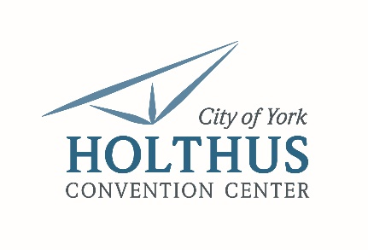

Holthus Convention Center | Event Setup Crew

Summary: The Convention Center Event Setup Crew is responsible for setup, breakdown and general support for events. He/she must be able to work variable hours, that may include a combination of weekdays, late nights and weekends. Willing to be flexible with school and activity schedules.

Essential Duties and Responsibilities
- Provide necessary facility support and services to successfully stage and accommodate events including the physical setup of tables, chairs, linens, staging and additional equipment/supplies as needed.
- Ensure event/room setups and break downs are completed accurately, safely and efficiently according to event plan and seeing diagrams through to completion
- Assist with basic cleaning of facility on an as needed basis. Duties include, but not limited to, trash removal, vacuuming and sweeping/mopping.
- Other duties as assigned

General Skills
- Strong organizational and planning skills
- Attention to detail
- Ability to follow written and verbal instructions
- Must be able to work quickly and efficiently in time crunch
- Professional presentation, appearance and work ethic
- Must be able to exert up to 50 lbs. occasionally and/or 25 lbs. frequently

Required Education/Experience
- 1 to 3 years of general work experience
- Strong customer/client service skills and a strong work ethic
- Flexible schedule with varying hours between weekdays, evenings and weekends
- Must be willing to work late nights if needed

For more information or to apply contact:
Terri Carlson | 402.363.2675 | tcarlson@cityofyork.net

